**CI/CD Pipelines**

* This project has the following architecture  
  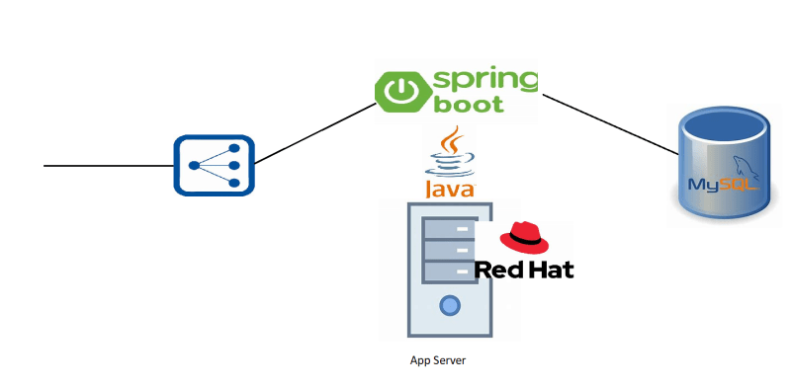
* The working style of the developers  
  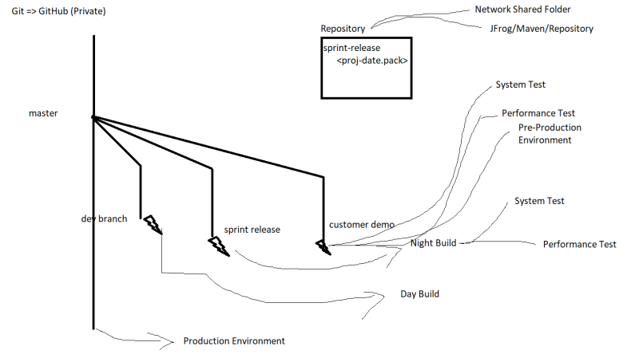
* We need to set up Continuous Deployment for CI/CD Pipeline
* Lets Start with Night Build
  + System Test Env
  + Performance Test Env
* Background:
  + You already have virtual machines available for System Test Environment & Performance Test Environment.
* Can you write down the steps in the pipeline
* Note: If any steps fail, build will be marked as failure and an email with failure information will be sent across to all the team members
* Get the Latest version of Code available at scheduled time
* Build the Package
* Run the unit tests and publish reports
* Run the integration tests (if any) and publish the reports
* Run the Code Analysis and publish the reports
* Run the Code Coverage and publish the reports
* We need to publish the build artifact (package) to the Repository
* We need to perform configuration management (Ansible)
* We need to run the System Tests in System Test Environment and publish the reports
* We need to run the Performance Tests in Performance Test Environment and publish the reports
* Tools:
  + Infrastucture: AWS / Azure / On-premise (Physical / VMWare)
  + Version Control System: Git (GitHub, BitBucket, Azure Source Repos, AWS Code Commit )
  + CI/CD Engine: Jenkins, Azure DevOps
  + Static Code Analysis & Code Coverage: SonarQube
  + Artifact Repository: JFrog/Artifactory
  + Configuration Management: Ansible
  + Performance Test Harness: JMeter
  + System Test Harness: Selenium (Web Application), Post man (Web API)